Trigger Name : trg_PreventMultiExamInsert
Table : Student_Exam_Questions
Type : AFTER INSERT
Purpose : Prevent a student from being inserted into more than
one exam at the same time in a single insert operation.
Note : This ensures that one student cannot be registered
in multiple exams in one go.

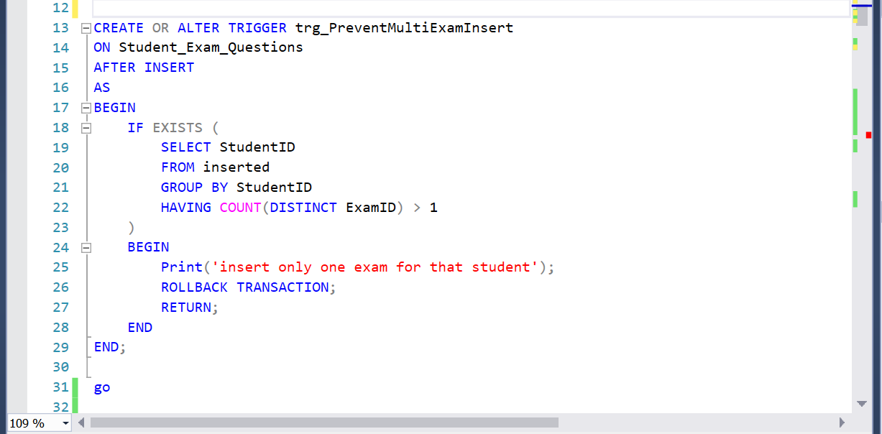

Trigger Name : trg_PreventExamConflict
Table : Student_Exam_Questions
Type : AFTER INSERT
Purpose : Prevent a student from having two exams that overlap
in time (exam schedule conflict).
Logic : Compares new exam's StartTime/EndTime with existing
exams for the same student.

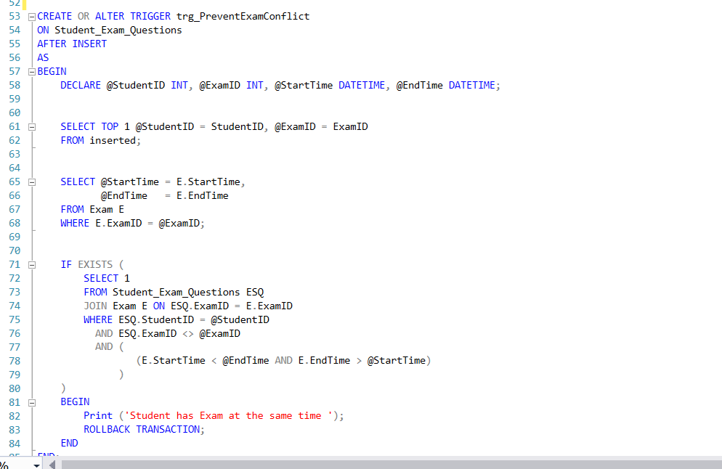

Trigger Name : trg_PreventInvalidExamRetake
Table : Student_Exam_Questions
Type : AFTER INSERT
Purpose : Control exam retake rules:
- A student cannot take the same course's final exam (ExamType = 'E') more than once.

- A student can only take a corrective exam (ExamType = 'C') if they failed the final exam.

- If a student fails a corrective exam, they cannot retake or enter any exam for that course again.
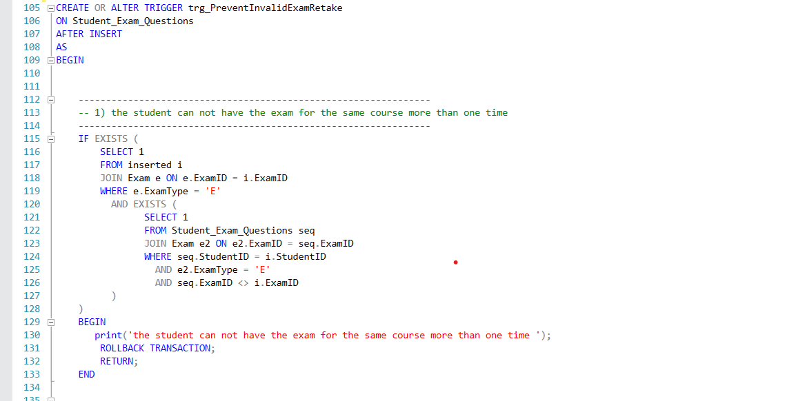

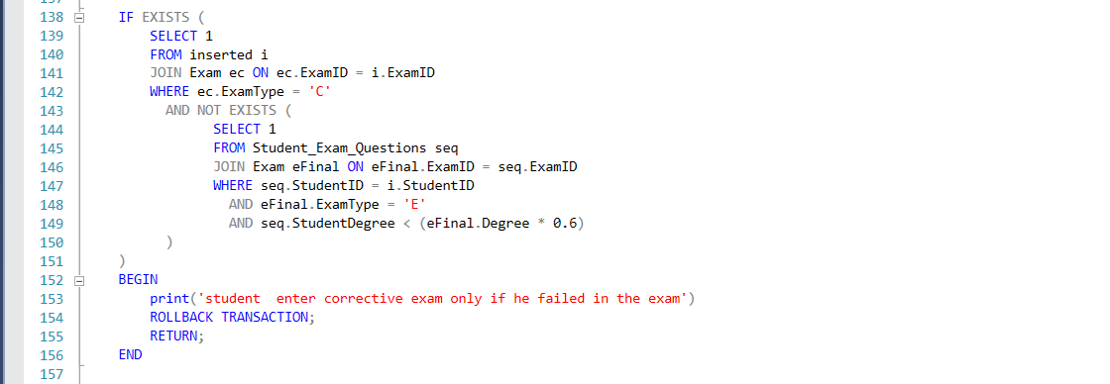

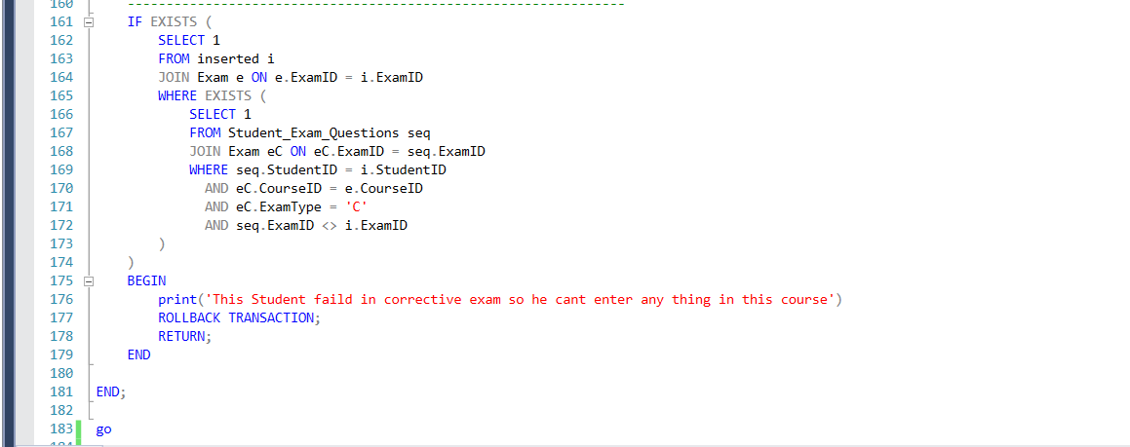

Trigger Name : trg_Check_Exam_Time
Table : Student_Answer
Type : AFTER INSERT
Purpose : Ensure students can only insert answers
during the valid exam Time (StartTime to EndTime).

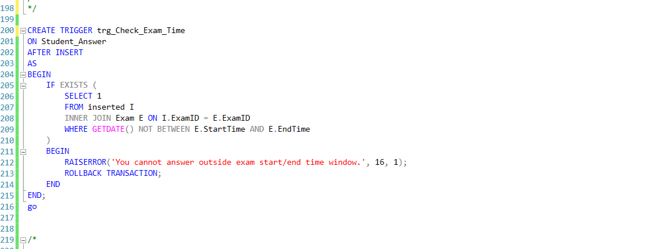

Trigger Name : trg_Check_Exam_Duration
Table : Student_Answer
Type : AFTER INSERT
Purpose : Enforce per-student exam duration.
Logic : Calculate student's first answer time
and disallow answers after (first answer + Duration).

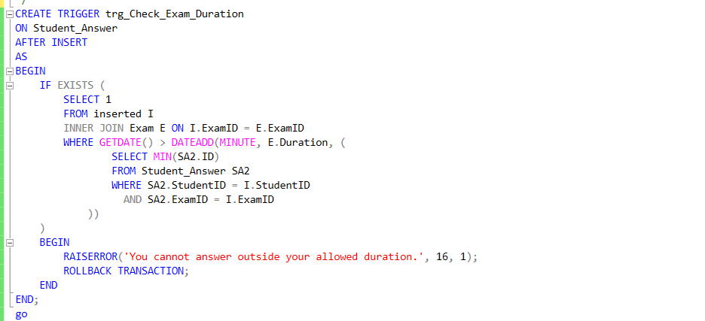

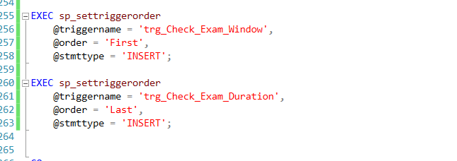

Trigger Name : trg_Audit_Users
Table : Users
Type : AFTER INSERT, UPDATE, DELETE
Purpose : Audit log for all changes in Users table.
Details :
- On INSERT → log new data
- On DELETE → log old data
- On UPDATE → log both old and new data
- Saves username and timestamp

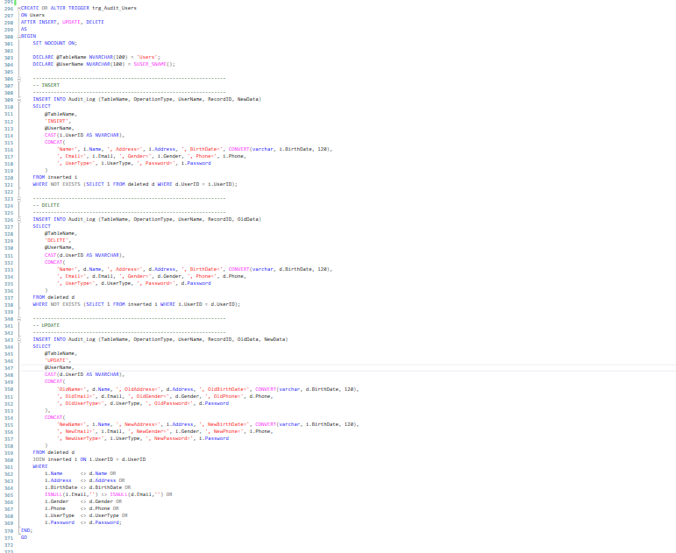

The indexes :

